Experiment 1

Familiarization with Laboratory Instruments: Oscilloscope, Function Generator, Digital Multimeter, and DC Power Supply

OSCILLOSCOPE
Oscilloscope is probably the single most versatile and useful Test and Measurement instrument invented for Electronic measurement applications. It is a complex instrument capable of measuring or displaying a variety of signals. This is the basic equipment used in almost all electronic circuit design and testing applications. The major subsystems in an oscilloscope are Power supplies (high and low voltage supplies), Display subsystem, Vertical and Horizontal amplifiers and display systems. There are two major types of oscilloscopes, viz. Cathode Ray Oscilloscopes (CRO) also called Analog Oscilloscopes, and Digital Storage Oscilloscopes (DSO), occasionally called Digital oscilloscopes. There are some analog oscilloscopes which also have the extra facility to store waveforms in digital form; these are called mixed-mode (i.e. Analog/Digital) oscilloscopes.

The main use of an oscilloscope is to obtain the visual display of an electrical voltage signal. If the signal to be displayed is not in the voltage form, it is first converted to this form. The signal voltage is then transmitted to the oscilloscope along a cable (usually a coaxial cable) and enters the oscilloscope where the cable is connected to the scope input terminals. Often the signal at this point is too small in amplitude to activate the scope display system. Therefore, it needs to be amplified.

A.1 Analog Oscilloscope: Cathode Ray Oscilloscope (CRO)
In a CRO the X and Y signals are applied to the horizontal and vertical plates, respectively of the cathode ray tube (CRT) after amplification. Within the CRT, an electron beam is created by an electron gun. The electron beam is focused and directed to strike the fluorescent screen, creating a spot of light, where impact is made with the screen. The beam is deflected vertically in proportion to the amplitude of the voltage applied to the CRT vertical deflection plates. The amplified input signal is also monitored by the horizontal deflection system. This subsystem has the task of sweeping the electron beam horizontally across the screen at a uniform rate. A sawtooth type signal (a triangular/ramp signal with long time duration for the rising part of the ramp and very small time duration for the falling part) is internally generated in a CRO as a time-base signal (sweep signal). This signal is amplified and applied to the horizontal deflection plates of the CRO. Again, the beam is deflected horizontally in proportion to the amplitude of the voltage applied to the CRT horizontal deflection plates. The simultaneous deflection of the electron beam in the vertical direction (by the vertical deflection system and the vertical deflection plates) and in the horizontal direction (by the time-base circuitry and the horizontal deflection plates) causes the spot of light produced by the electron beam to trace a path across the CRT screen. For example, if the input signal to the CRO were a sine wave, the trace produced on the CRT screen will be a sine wave. It is important to obtain a stable display on the CRT screen. If the input signal is periodic and the time base circuitry properly synchronizes the horizontal sweep with the vertical deflection, the spot of light will trace the same path on the screen over and over again. For a periodic signal the input signal can be synchronized with the time-base signal using the Trigger controls and the time base controls. If the frequency of the periodic signal is high enough (say greater than 40 Hz), the repeating trace will appear to be a steady pattern painted by solid lines of light on the screen.

A.2 Digital Storage Oscilloscope (DSO)
A DSO samples the input waveform and uses an analog-to-digital converter (or ADC) to convert the voltage being measured into digital information. It then uses this digital information to reconstruct the waveform on the screen. The ADC in the acquisition system samples the signal at discrete points in time and converts the signal's voltage at these points to digital values called sample points. The horizontal system's sample clock determines how often the ADC takes a sample. The rate at which the clock "ticks" is called the sample rate and is measured in samples per second. The sample points from the ADC are stored in memory as waveform points. More than one sample point may make up one waveform point.
Together, the waveform points make up one waveform record. The number of waveform points used to make a waveform record is called the record length. The trigger system determines the start and stop points of the record. The display receives these record points after being stored in memory.
Depending on the capabilities of the oscilloscope, additional processing of the sample points may take place, enhancing the display. Pretrigger may be available, allowing you to see events before the trigger point. Fundamentally, with a digital oscilloscope as with an analog oscilloscope, you need to adjust the vertical, horizontal, and trigger settings to take a measurement.
Major specifications of the DSO used in the Esc 102 Lab
Model and Manufacturer : GDS-1062, M/s GW Instek, Taiwan,
Bandwidth : 60 MHz
Vertical sensitivity : 2 mV/div to 5V/div (1-2-5 increments)
Accuracy : ± 3 % x |Readout| + 0.1 div + 1 mV
Horizontal range : 1 ns/div to 10 sec/div, (1-2-5 increments)
Signal acquisition : sampling 250 M Sa/sec
Vertical resolution 8 bits
Record length 4k points maximum
Display : LCD, 5.6 inch, TFT
Resolution 234 (vertical) x 320 (Horizontal)
Graticule 8x10 divisions
Interface : USB
Power consumption : 18 W, 40 VA maximum
Dimensions : 341.5(W) x 162.3 (H) x 159 (D) mm
Weight : 2.5 kg

This CRO will be used as a measuring equipment for all the experiments. Detailed description of the various subsystems of a CRO is beyond the scope of this course. Operational details and specifications of the DSO are given at the end.

For more details on different types of oscilloscopes and their applications, you may refer to the following material on the web: “XYZs of Oscilloscopes: Primer”, by M/s Tektronix Inc., USA.
URL: http://www.tek.com/Measurement/App_Notes/XYZs/

FUNCTION GENERATOR
Another major equipment commonly in electronic circuit applications, is a Function Generator (FG). As the name indicates, a Function Generator generates different voltage signals, such as Sine, Pulse, Triangle. The most commonly required signals in electronic circuits are Sine and Pulse. Sine wave signals find their use mostly in Analog circuits, such as amplifiers, filters, etc. Pulse signals are useful in testing the time response of circuits and also as Clock signals in Digital circuits. In a general pulse signal, the high and low level time periods are different. Square wave is a special case when the periods are equal.

In a FG by the touch of a button one can choose a variety of signals. This is possible because of the fact that one can obtain different signals from a starting signal using waveshaping circuits. The synthesized function generators, the waveforms are generated by digitally stored signals through digital to analog converters. In the Esc 102 lab you will be using the Model SFG2110 Synthesized Function Generator (by M/s GW Instek, Taiwan) which is a 10 MHz function generator.

DIGITAL MULTIMETER
Digital multimeter (DMM) is a cheap and portable instrument used for measuring voltages (dc and ac), currents (dc and ac) as well as resistances – hence the name multimeter. Earlier, analog multimeters were
used for measuring the above. Analog multimeters used a standard milliammeter with different calibrated dials for voltages, currents and resistances. These instruments were bulky and lacked accuracy. Presently, analog multimeters are seldom used. Digital multimeters are more accurate, handy and easy to use. The DMM used in the Esc 102 laboratory is Model DM3540A, manufactured by M/sMotwane India. It has an input resistance of 20 Mohms, which makes it an excellent instrument for measuring voltages. In addition to the standard functions (voltage, current and resistance measurements) it also has auto-ranging, diode check and continuity check facilities.

In the Esc 102 lab you will be using the DMM mainly for measuring DC voltages. DMMs cannot measure ac signals above 50 Hz. Also, they are not very accurate for current measurements. They are mostly used for measuring voltages and resistances.

BASIC OPERATIONS OF THE DSO AND FUNCTION GENERATOR
Read the following sections carefully and familiarize yourself with the basic operations of the DSO and the FG.

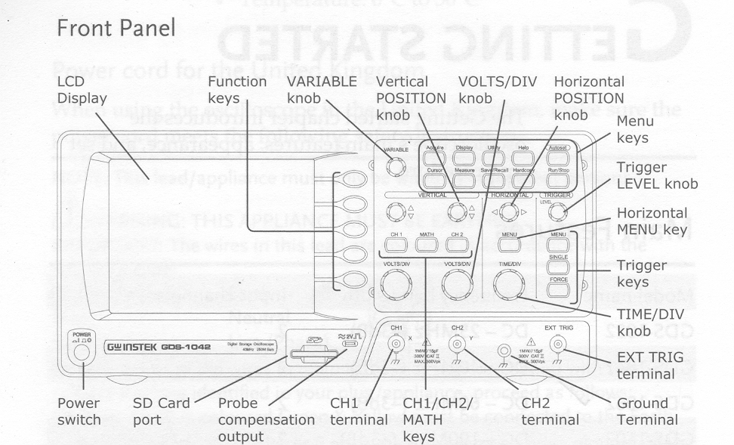
Basic DSO Operations
A schematic diagram of the DSO front panel is shown above. Other than the LCD display, There are Five major sections on the front panel of the DSO:

Section 1 – The five function keys located on the side of the display
Section 2 – the section below the display consisting of Power switch, and probe compensation output (calibrated source).
Section 3 – A variable knob and Ten Menu keys located on the top side to the left of the display.
Section 4 – Knobs and buttons located in three columns at the centre part, indicated as: VERTICAL, HORIZONTAL, and TRIGGER.
Section 5 – Located at the bottom part to the left of the display are input BNC sockets for CH-1, CH-2 and External Trigger terminals, and an extra socket for GND.

DSO operations require the use of a combination knobs and buttons. You need to familiarize yourself well with all the basic operations in order to perform experiments and make measurements using the DSO in the Esc 102 lab.
- Channels CH-1 and CH-2
Note that the DSO can display signals simultaneously on Two channels. The signal display part of the LCD screen is 10cm (X-axis) long and 8cm (Y-axis) high. For convenience these channels are indicated with different colours. Signal connected to Channel 1 (CH-1) would appear YELLOW on the LCD screen. Numera1-1 is also indicated on the extreme left side of the display. CH-1 controls are also given yellow colour. By pressing the yellow button (CH 1), this channel (and display) can be turned on or off. The Volts/Div knob indicates the Y-scale in volts/full div or volts/cm. Signal to CH-1 should be connected to the BNC connector seen just below the Volts/div knob.

Similarly, the signal to CH-2 should be connected to the socket below the CH-2 Volts/div knob. CH-2 display would appear blue on the LCD screen. Numeral-2 is also indicated.

- CH-1 and CH-2 Coupling Modes
Press the required channel button (CH-1 or CH-2). Now sub-menu for that channel would appear at the left side of the screen. Choose the top option, “Coupling” by pressing the first function key. The current coupling mode would be displayed below the line “Coupling”. The three possible coupling modes are DC(two lines: solid line and broken line), AC(sine wave), and GROUND (ground sign). As you press this function key the coupling modes keep changing. The present mode would be displayed below the “Coupling” function.
The most common coupling mode is DC, which would enable you to measure both dc and ac levels of the signal. In the AC mode, the dc content of the signal would be removed. GROUND mode is used to choose the reference zero level for the Y-axis. In this mode DSO disconnects the input signal and connects the channel to ground.

- Triggering the display
Proper triggering of the signal is required to get a stable display. When the signal is properly triggered, a message in green colour “Trig’d” would appear on the top. By pressing the “MENU” button in the “TRIGGER” column (extreme right column), various options for triggering are obtained. These are

Type: Edge, Pulse, Video
Source: CH 1, CH 2, External, Line
Slope/Coupling: Slope(+ve/ –ve), Coupling (DC/AC), Rejection (Off/LF/HF), Noise Rej(Off/On)
Mode: Auto
For normal use choose Type: Edge, Source: CH1 or CH2, Slope (+ve or –ve), Coupling: DC

- Single and Continuous Trigger Modes
The signals to be displayed may either be continuously triggered and acquired by the DSO or just once. By pressing the “SINGLE” button on the Trigger submenu (extreme right column), signals are acquired just once, the instant immediately after pressing this button. A message “Stop” appears on the top of the LCD display to indicate that the acquisition has been stopped. The trigger mode also turns to “Normal” as indicated at the extreme right bottom. This mode is useful only when you want to make a measurement and are not interested in displaying the input signals in a continuous fashion.
Most of the time one is interested in the continuous trigger and acquisition mode. To get back to the continuous mode, press on the lower most function button indicated “Mode normal” It would make the trigger mode continuous and the “Mode Auto” message would appear at the lower most function. Now the channels would be continuously updated. The message “Trig’d” would appear at the top to indicate that the mode is continuous and that the signal is triggered properly. Notice also the frequency of the signal displayed at the bottom of the LCD screen.

- Horizontal Functions
There are three controls under HORIZONTAL (middle column). Top one is the horizontal position knob used to move the display in the X-direction. Bottom one is the “TIME/DIV” knob used to select the timebase scale (X-scale). This can range from 10sec/div to 1ns/div. The current time base
scale setting will be displayed at the bottom, a little left to the centre line. A proper setting of the channel Volts/div and Time/div are required to get a clear display. The middle button “MENU” in this column is used to choose the Display mode.

- Display Modes: Main and XY Modes
Press the “MENU” button, located just above the TIME/DIV knob located among the Horizontal controls (middle column). For normal operations, where you want to display the input signal continuously, the mode should be “Main”. To get the XY mode, press the XY function key in this menu. XY mode is occasionally used to get the XY plot of the two signals connected to CH-1 and CH-2. In the XY mode, CH-1 signal is taken as the X-axis input and CH-2 the Y-axis.

- AUTOSET Function
This button may be thought of as the ‘panic’ button. This button may be pressed when you think that you are lost and needs help (with regard to displaying the signals on the DSO properly!). Once the AUTOSET button is pressed (extreme top right button) the DSO measures the amplitudes and time periods of the input signals connected to CH-1 and CH-2 and automatically chooses the correct Volts/Div, Time/Div, and Trigger mode settings.

Basic Function Generator (FG) Controls
The main purpose of the FG is to give you the signal you require, sine wave, square wave, or triangular wave. You need to choose both the frequency and amplitude of these functions. The FG knobs and buttons explained below would familiarize you as to how you choose a particular function, its amplitude and frequency. Note that the FG output is taken through a co-axial cable from the Waveform Output socket.
Front View of the Function Generator:
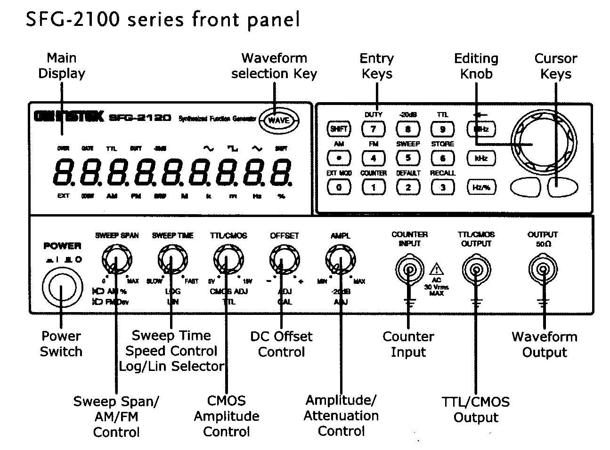
Refer to the front view figure in the previous page.

The function generator uses Direct Digital Synthesis (DDS) technology to output stable waveforms. In DDS, the waveform data is contained in and generated from a memory. A clock controls the counter for memory addressing. The output of the digital memory is converted to analog signal by a digital to analog converter (DAC) followed by a low pass filter.

The information about the type of waveform selected and the frequency are displayed on the display panel of the function generator.

- Waveform Selection Key – This key selects a sine wave, a square wave or a triangular wave.
- Cursor Keys – Moves the editing point left or right in case of manual editing.
- Amplitude/ Attenuation Control –Sets the sine/ square/ triangular waveform amplitude. Turn left to decrease or turn right to increase the amplitude. When pulled out, attenuates the waveform by -20 bB. The -20dB display turns on.
- DC Offset Control – When pulled out, sets the DC offset level for sine/ square/ triangle waveform. Turn left to decrease or turn right to increase the offset. The range is -5V to +5V, in 50 Ohm load.
- CMOS Amplitude Control – This knob becomes effective when the TTL/CMOS output is enabled. When the knob is pressed TTL output is selected. When the knob is pulled out, CMOS is selected as output. The level of the CMOS signal is selected by rotating the knob.
- Waveform Output – The connector outputs sine, square, and triangular waveform. The output impedance is 50 .
- TTL/CMOS Output – Outputs TTL or CMOS output waveform.
- Counter Input – Accepts signals for frequency counting (max. amplitude is AC 30 V rms).

Important Note: Do not turn off the DSO or the FG at anytime during your experiment. They should be left on till the experiment is over.

EXPERIMENT: Observing Signals from the FG on the CRO

1. Displaying various functions from the FG on the DSO
*(a) Connect the output of the FG to the CH1 of the DSO using 2 cables and the Microboard (Breadboard). Choose Sine function and adjust the controls to get a 5 sin ωt (freq = 1 kHz on the FG). Note that the peak-to-peak voltage of the sine will be 10 Volts. You will need to adjust the Trigger Level controls etc of the DSO to get a stable display. Measure the time period of the sine wave as accurately as you can (choose a time base sweep rate such that the sine wave is well expanded). Compare your answer with the nominal value of 1 ms. Also check the frequency reading on the DSO. Sketch the waveform.
*(b) Change the function to Square and Triangle without changing the frequency. Observe and sketch the waveforms obtained.
*(c) Study the effect of Level and Slope controls of Trigger on the waveform displayed.

- Effect of Channel Input Coupling Modes (DC and AC modes)
*(a) Set CRO CH1 Input to DC Mode. Choose Pulse Mode and display the FG Function output on the CH1 of the DSO. Set the FG to obtain a Square wave going from 0 to 7V. Adjust the Vertical position of the display such that the 0V level is at the middle of the LCD display. Observe and sketch the waveform. (Note: In the DC mode of the channel, the signal is connected as it is to the Vertical Amplifier. Hence any DC level already present in the signal is shown in the display also).
*(b) Switch the CH1 input mode to AC. Observe and sketch the change in the display. Explain the result. (Hint: In the AC mode, the DSO inserts a Capacitor in series with the signal before connecting it to the Vertical amplifier).

- X-Y Plot using DSO
One of the useful features in a modern CRO is the facility of XY Plot. This facility can be used to display the output waveform of a circuit as a function of the input signal.
(a) Adjust the FG and display 5 sin ωt (freq = 1 kHz on the FG) on CH1. Put the CH1 and CH2 input modes to GND. Put the scope in X-Y mode. Adjust the X and Y positions of the display so that the dot displayed on the CRT is located at the origin.
*(b) Now remove the GND modes and choose DC modes for both CH1 and CH2. Connect the sine wave signal to both the channels. Observe the waveform and sketch it.
*(c) Use a simple potential divider using two 10k resistors (On the breadboard, connect two 10k resistors in series across the FG signal. Take the output from the mid-point and GND). Connect the FG output as X and the potential divider output as Y. Observe and sketch the waveforms.

- Limitations of a DSO
Input Equivalent Circuit of the CRO: Notice 1 MOhm, 15 pF written beneath the CH1 and CH2 input BNC sockets. This is to tell the user that the CRO input channel is equivalent to a 1MOhm resistor in parallel with a 15pF capacitor.
*(a) Effect of finite input resistance: Make a simple potential divider using two 10 kOhm resistors. Connect +5V from the Power Supply panel to the input of the divider. Observe the output of the divider on the CRO and measure it. Use a Digital Multimeter (DMM) and note the voltage output. Compare the results. Repeat the same, but now using two 1Mohm resistors instead of the 10 k resistors. Measure and note the output of the divider again using both CRO and DMM. Explain the result. Note that the DMM used in the Lab has an input resistance of 20 M Ohms.

Note: Results of the sections with a ‘*’ must be done and noted in your Lab Record.

